Supplementary Information

Supplementary Information 1 – Detail of the lynx spatially-explicit individual-based model

A complete description of the model following the Overview, Design concepts, and Details (ODD) protocol (Grimm et al., 2006, 2010) is provided in Supplementary Information 2.

Our lynx spatially-explicit individual-based model is made of four components (main text, Fig. 2). The first component represents the impact of road network on lynx survival via predicted collision probabilities. The second component represents the impact of land cover on lynx space use with the definition of different lynx habitat types. These first two components are spatial layers influencing the behavioral rules followed by simulated lynx individuals. The third component represents the initial lynx populations made of lynx individual’s locations and characteristics used to launch the SE-IBM. The fourth component details all SE-IBM rules including lynx demography, dispersal movement and establishment.

Impact of road network (SE-IBM 1st component)
We first built a risk model to predict collision probabilities between lynx and vehicles within the 1 km² resolution gridded study area. We used lynx mortality events recorded by the wolf-lynx monitoring framework implemented in France (Duchamp et al., 2012, Réseau Loup-lynx https://www.loupfrance.fr/suivi-du-loup/reseau-loup-lynx/), which represents 84 collision events recorded between 1982 and 2016, to train a logistic regression explaining lynx collisions using lynx presence and both road and environmental characteristics (Visintin, van der Ree, & Mccarthy, 2017; Visintin et al., 2018) (Table S1.1). We used the IGN route500 © for France (IGN ROUTE 500, 2018) and OpenStreetMap© for the other countries (Geofabrik OpenStreetMap, 2014) as data sources to extract total road length per cell and the type of roads of the longest road segment in each cell. We classified the road segments as “highways” (i.e., “Type autoroutier” in route500 © data, “motorway”, “motorway_link”, “trunk” and “trunk_link” in OpenStreeMap data), “main road” (i.e., “Liaison principale” in route500 © data, “primary” and “primary_link” in OpenStreeMap data), “secondary road” (i.e., “Liaison régionale” in route500 © data, and “secondary” and “secondary_link” in OpenStreeMap data) and “local road” (i.e., “Liaison locale” in route500 © data, “tertiary”, “tertiary_link” and “unclassified” in OpenStreeMap data). For environmental characteristics, we used Corine Land Cover© at 100 m of resolution for all Europe (Copernicus, 2012) to calculate the proportion of urban area in each cell (i.e., human presence). The best model identified included the total road length, the type of road of the longest road segment and the proportion of urban area (Table S1.2). Distance to highways and human density were also tested to explain lynx-vehicles collisions but were not significant. We used this model to predict a collision probability, ranging between zero and one in each cell of our study area, to create the “collision layer” (Fig. S1.1). Lynx presence was also included as explanatory variable in the model. To predict collision probabilities, we defined the lynx as present everywhere on the gridded study area because simulated individuals in the SE-IBM suffer from collision probability on the cells they are located so the mortality value should already account for the lynx presence. Study area grid cells without road intersecting them have a zero-collision probability.

Table S1.1: Statistical details for the non-categorical variables included in the best model identified to explain lynx-vehicle collisions.

Variable | Unit | Mean | Standard deviation | Minimum value | Maximum value
Lynx presence | Years of presence | 14.5 | 12.0 | 0 | 35
Total road length | Meters | 1212 | 728 | 0 | 8084
Urban area | Percentage | 7.9 | 16.9 | 0 | 100

Table S1.2: Parameter estimates for the best model identified to explain lynx-vehicle collisions (logistic regression parameters).
Parameter | Estimate | Standard error | Z value | P-value
Intercept | -6.29204 | 0.24903 | -25.267 | < 2e-16
Lynx presence | 1.11454 | 0.15664 | 7.115 | 1.12e-12
Total road length | 0.34289 | 0.10107 | 3.392 | 0.000693
Longest segment == highway | 1.69306 | 0.53300 | 3.176 | 0.001491
Longest segment == main road | 1.96672 | 0.27082 | 7.262 | 3.81e-13
Longest segment == secondary road | 0.53213 | 0.31437 | 1.693 | 0.090517
Urban area | -0.41059 | 0.16709 | -2.457 | 0.013996

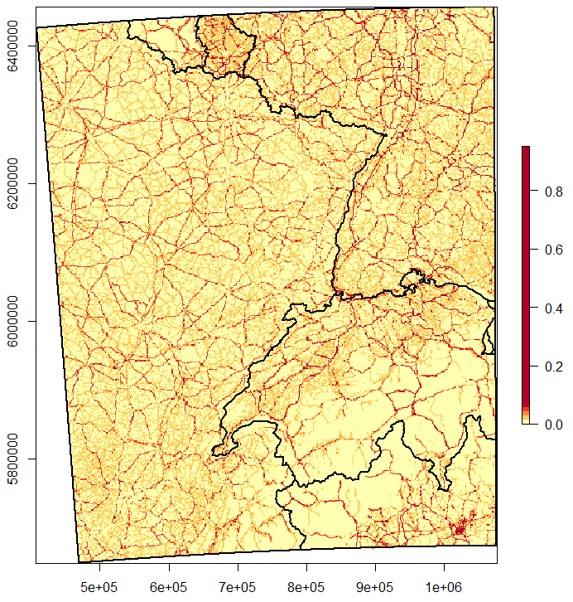
Figure S1.1: “Collision layer” with collision probabilities between lynx and vehicles estimated between zero and one (yellow to red color scale). Collision probabilities are assigned to each cell of the gridded landscape over the whole study area (black rectangle) used in the lynx SE-IBM using the collision model. Limits of the countries (main text, Fig. 1) are overlaid in black over the map.

Impact of land cover (SE-IBM 2nd component)
We built a habitat model to define a habitat type for each cell within the 1 km² resolution gridded study area. We used a multi-year occupancy model (Isaac et al., 2014; Outhwaite et al., 2018) in a Bayesian framework to explain regular lynx presence using land cover types important to lynx (agricultural fields, forest and open land), the distance to highways (Basille et al., 2013), and human density (Table S1.3). The model was calibrated using French data for the lynx presence from 1994 to 2017 (data: Réseau Loup-Lynx https://www.loupfrance.fr/suivi-du-loup/reseau-loup-lynx/). The model used both lynx detection and non-detection data over the surveyed area each year (https://ecologicalstatistics.shinyapps.io/flexdashboard_effort/). We used Corine Land Cover© at 100 m of resolution for all Europe (Copernicus, 2012) to calculate the proportion of agricultural and cultivated fields, forest, pasture and open land in each cell. We used the IGN route500 © for France (IGN ROUTE 500, 2018) and OpenStreetMap© for the other countries (Geofabrik OpenStreetMap, 2014) as data sources to calculate the distance from each cell center to the nearest highway. We also used IGN© data for France (IGN ADMIN-EXPRESS-COG, 2018) and NASA© data for the other countries (CIESIN GPWv4, 2015) to calculate the mean human density per cell on a log scale. Finally, we also added a yearly fixed effect and a random site effect to the model. The best model identified to explain lynx presence included presence of agricultural fields, forests, and open lands, distance to highways and human density. Parameters values (Table S1.4) were estimated for the occupancy on the logit scale. Shrub cover and road length were also tested to explain lynx presence but were not significant. We used the inverse logit function to predict lynx occupancy probability in our entire gridded study area for the last year (i.e., 2017). We then categorized the cells to obtain a “habitat layer” with the four habitat types defined by the habitat categorization of Kramer-Schadt et al. (2004): “breeding”, “dispersal”, “matrix” and “barrier” (Fig. S1.2). All cells where lynx occupancy was predicted as non-null (above or equal a threshold of 0.01) were considered “breeding” habitat. All forested areas not already “breeding” habitat were considered as “dispersal” habitat. Cells with more than half of their surface covered by water or urban area defined by Corine Land Cover© (Copernicus, 2012) were considered “barrier” for lynx movements. The rest was considered “matrix” area (i.e., habitat not favorable for lynx but that can be traversed by dispersers). The map of categorized cells for our study area defined the “habitat layer” used in the SE-IBM (Fig. S1.2).

Table S1.3: Statistical details for the variables included in the best model identified to explain lynx presence.
Variable | Unit | Mean | Standard deviation | Minimum value | Maximum value
Arable lands | Percentage | 19.0 | 24.0 | 0 | 100
Permanent cultures | Percentage | 2.8 | 8.9 | 0 | 100
Pastures | Percentage | 15.2 | 18.3 | 0 | 100
Forests | Percentage | 35.1 | 21.3 | 0 | 100
Open lands | Percentage | 4.2 | 14.1 | 0 | 100
Distance to highways | Meters | 18771 | 15448 | 0 | 62125
Human density | Log (density per km²) | 3.74 | 1.31 | -5.04 | 8.82

Table S1.4: Parameter estimates for the best model identified to explain lynx presence (Bayesian occupancy model parameters).
Parameter | Mean | Standard deviation
Arable lands | -1.06 | 0.23
Permanent cultures | -0.85 | 0.24
Pastures | 0.68 | 0.15
Forests | 1.67 | 0.16
Open lands | 0.49 | 0.17
Distance to highways | -0.70 | 0.14
Human density | 0.77 | 0.15
Yearly fixed effect (estimate for the last year) | -6.57 | 0.27

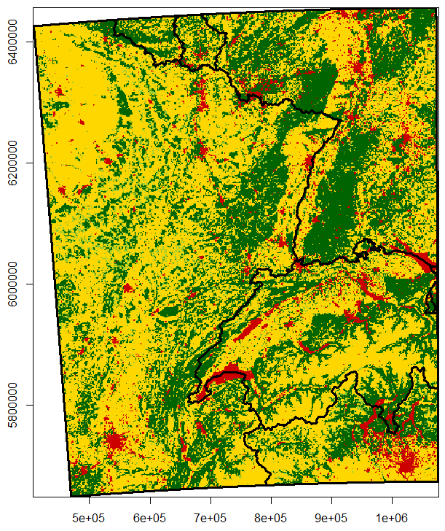
Figure S1.2: “Habitat layer” with lynx habitat types as breeding habitat (dark green), dispersal habitat (light green), matrix (yellow) and barrier (red). Habitat types are assigned to each cell of the gridded landscape over the whole study area (black rectangle) used in the lynx SE-IBM using the habitat model. Limits of the countries (main text, Fig. 1) are overlaid in black over the map.

Lynx initial populations (SE-IBM 3rd component)
The initial populations to launch the SE-IBM were built with generated locations and characteristics for the lynx populations using the best data available at the time of the study (Fig. S1.3). We used cells of regular lynx presence for France (for the time period of 01/04/2013 to 31/03/2017 from the Réseau Loup-Lynx, main text, Fig. 1), Switzerland (for the time period of 01/01/2015 to 31/12/2017 from the KORA, main text, Fig. 1) and Germany (for the time period of 01/05/2017 to 30/04/2018 from the Bundesamt für Naturschutz, main text, Fig. 1). In these cells, we extracted “breeding” and “dispersal” areas and sampled random lynx locations in these areas to locate individuals within the different populations. In France, we used the most reliable lynx density estimate (1.14 lynx per 100 km²; Gatti et al., 2014), regardless of differences in local densities (Gimenez et al., 2019), to convert the area of regular presence into a number of individuals to create. Ninety-two individuals were generated and dispatched over “breeding” and “dispersing” areas in France: in the Vosges Mountains (500 km² of presence), in the French Jura (7,700 km² of presence) and in the French Alps (500 km² of presence). A density of 1.14 lynx per 100 km² may be an over- or an under-estimate of the lynx density in certain areas but in the absence of local density for each French population, we used this mean value. On average, this method led to 4.5 individuals in the French Alps (sd = 2.1), 77.0 individuals in the French Jura (sd = 3.4), and 8.4 individuals in the Vosges Mountains (sd = 2.7). In Switzerland, we generated 230 individuals distributed in the different areas of presence according to estimated local population sizes in 2017 (data: F. Zimmermann, pers. comm.). In Germany, 11 lynx (i.e., reintroduced lynx still alive and their offsprings) were identified in the Palatinate at the end of April 2018 (Scheid, Germain, & Schwoerer, 2021) and four male lynx were identified in the Black Forest (Wölfl et al., 2021). Therefore, we generated 11 lynx in Palatinate Forest and four lynx in the Black Forest area.
Except for reintroduced individuals for which we knew their characteristics, we randomly assigned individuals’ sex (male or female) according to the ratio 1:1 usually observed at birth (Breitenmoser et al., 1993; Jedrzejewski et al., 1996). We also randomly assigned an age between 2 and 15 as lynx usually live until 15-17 years old (e.g., Breitenmoser-Würsten, Vandel, et al., 2007). Age is defined as zero for the first year of life, one during the second year of life, etc. For the Palatinate part of the Vosges-Palatinian population, we assigned known age and sex (five females and six males). In the Vosges Mountains, only males were detected in 2017 thanks to the camera trap survey design implemented (Charbonnel & Germain, 2020) and no case of reproduction was reported during the years preceding our analyzes. We then only defined males for the individuals located in the Vosges part of the Vosges-Palatinian population, with ages randomly generated. We also only defined males for the Black Forest population. All generated individuals were defined as “disperser” to avoid the bias of defining territories by ourselves. They find their territories on their own as defined by the SE-IBM rules.
We also used lynx regular presence data to define the “population layer” (Fig. S1.3). This layer took the gridded study area where each cell was assigned one of the four lynx populations (main text, Fig. 1), taking the population from the closest lynx regular presence cell. This “population layer” delineates population areas. It is used to define in which population kitten were born and identified individual exchanges between populations.

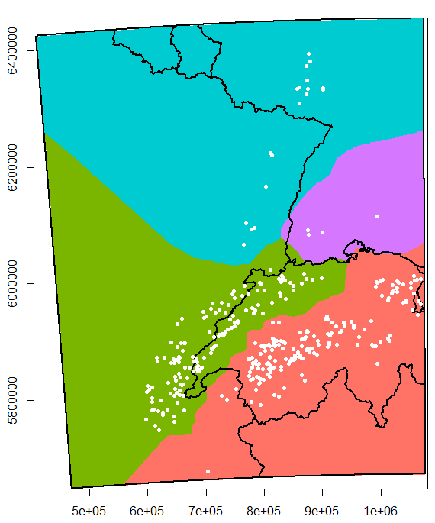
Figure S1.3: “Population layer” with the example of an initial population over the whole study area (black rectangle) used in the lynx SE-IBM using the habitat model. Limits of the countries (main text, Fig. 1) are overlaid in black over the map. Areas for the Vosges-Palatinian (blue), Black Forest (purple), Jura (green) and Alpine (red) populations were defined using the cells of lynx regular presence as in 2017-2018. Each cell of the gridded study area was assigned the population from its closest cell of lynx regular presence. White dots represent one initial population (i.e., simulated lynx released at the beginning of one simulation replicate) generated using the cells of lynx regular presence, the density or number of lynx in each population and the “habitat layer” to place these theoretical individuals in breeding or dispersal habitats. A different initial population was used at each simulation replicate; we used the same cells of lynx regular presence, the same density or number of lynx in each population and the same “habitat layer”, only the generated locations, and chosen sex and age for unknown individuals, were different.

SE-IBM rules according to lynx ecology (SE-IBM 4th component)
Lynx individuals are simulated over a landscape represented as a grid of 1 km² resolution, covering the whole study area and encompassing the four lynx populations (main text, Fig. 1). The gridded study area resolution corresponds to lynx’s perceptual range (Haller & Breitenmoser, 1986) as well as to the resolution of previous lynx IBMs (Kramer-Schadt et al., 2004, 2011; Kramer-Schadt, Revilla, & Wiegand, 2005). Two variables characterize the gridded study area: a probability of lynx-vehicle collision between zero and one (“Collision layer”, Fig. S1.1) and a habitat type among “breeding”, “dispersal”, “matrix”, and “barrier” (“Habitat layer”, Fig. S1.2). Simulated individuals are characterized by their “disperser” (i.e., not established on a territory and in search of one) or “resident” status (i.e., established on a defined territory), their age and their sex.
Simulated resident individuals follow rules on a yearly time step (Fig. S1.4). They do not move (i.e., their movements inside their territory are not simulated), they hold a territory and they may reproduce once a year. They suffer two types of annual mortality: a fixed baseline mortality and a spatial one derived from the “collision layer”. Simulated dispersing lynx follow rules on a daily time step (Fig. S1.4). They do not have a territory yet and move every day along the gridded study area, searching for a place to establish themselves. Their dispersal movements (Fig. S1.5) and search for a territory (Fig. S1.6) are driven by the “habitat layer”. At each step, individuals can die from the spatial mortality derived from the “collision layer”, and daily from a fixed baseline mortality.

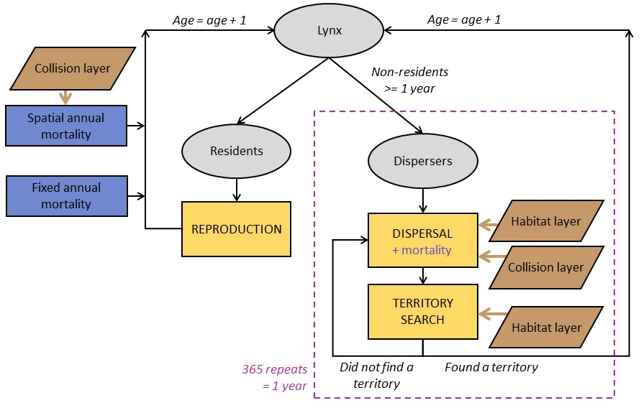
Figure S1.4: Diagram of the main structure of the SE-IBM with the main events affecting both resident and dispersing simulated lynx. Grey circles represent individuals. Yellow boxes represent SE-IBM main events, detailed in model description. Blue boxes or blue writing represent different mortality causes individuals suffer. Brown boxes represent environmental layers used in the SE-IBM and brown arrows point where behavioral rules are constrained by these layers. Black arrows indicate the flow of the model. Dispersers can go through dispersal and territory search every day during a year, as long as they do not find a territory (Figs. S1.5 and S1.6).

The modeling cycle starts with the dispersing individuals. Dispersers are individuals of one year old and older that do not hold a territory yet. Both dispersing males and dispersing females move on the gridded study area, one cell at a time, from one to 45 times per day (Fig. S1.5), following the same rules. The number of steps individuals move per day is sampled, each day for each disperser, from a non-linear distribution (Kramer-Schadt et al., 2004). Dispersers follow a correlated habitat-dependent walk in a two-step process: first, they favor their habitat preferences and then, maintain their previous direction with a certain probability (i.e., correlation factor; Kramer-Schadt et al., 2004). This movement process has been rigorously tested with inverse fitting, and “pattern-oriented modelling” (Kramer-Schadt et al., 2007) using telemetry data of six dispersing lynx (five females and one male) followed in the Swiss Jura Mountains between 1988 and 1991. First, dispersers choose in which habitat type they will move next. Dispersers favor “breeding” and “dispersal” habitats without distinction between the two when moving and tend to avoid “matrix” habitats. By contrast, they never use “barrier” habitats. The choice to move into the habitat “breeding/dispersal” or “matrix” depends on the types of their nine available cells for their next step (i.e., their eight surrounding cells plus the one they are currently on as they also can choose not to move). If the nine cells are all of one type, excluding the “barrier”, so they are either only “breeding/dispersal” (with or without “barrier”) or only “matrix” (with or without “barrier”), the only available habitat type is selected. If the available cells for an individual are a mix between “breeding/dispersal” and “matrix” habitats (with or without “barrier”), there is a probability of 0.03 times the number of “matrix” cells among the nine ones, to choose the “matrix” habitat for the next step (Kramer-Schadt et al., 2004). For example, if an individual has three “matrix” cells available, there is a probability of 0.09 that it will choose a “matrix” cell for its following location. Second, once the habitat type is selected, the choice of the particular cell to move on, among the ones of the selected habitat type, is given by the correlation part of the movement. Individuals follow a correlated movement with a probability equal to 0.5, except for the first step of the day where there is no correlated movement (Kramer-Schadt et al., 2004). If the movement is not correlated, the choice of the next cell among the ones of the selected habitat type is random. If the movement is correlated, the chosen cell is the one maintaining the most of the individual’s current direction among the ones of the selected habitat type. The chosen cell is then where the simulated lynx is moving to. Dispersers try to minimize their time spent in “matrix” habitat and they can use their memory to return to a previously visited “breeding/dispersal” habitat when needed. Lynx do not move more than nine cells inside “matrix” habitats, so if an individual already stepped nine consecutive times in “matrix” cells and the chosen cell for its next step is again of “matrix” type, it will use its memory and return to the last “breeding/dispersal” cell visited (Kramer-Schadt et al., 2004). Finally, dispersers rotate towards their chosen cell and move on their center. Once dispersers move to their next cell, they may die from the spatial mortality due to vehicle collision. This spatial mortality is the collision probability from the “collision layer” for the cell of their new location with a correction factor to transform the value into a per step collision mortality. If dispersers survive, they search for a territory. If found, they stop moving, establish a territory, and they will become resident the following year. Dispersers that do not find a territory to establish on their new location keep moving, as many steps during the day as simulated for them at the beginning of the day. At the end of the day, all individuals that dispersed during the current year may die from a fixed daily mortality probability (i.e., baseline mortality, Table S2.1). Dispersers that have not established during the day can move and search for a territory every day during the year. The daily spatial mortality is also applied to individuals which dispersed during the year but already found a territory during previous days. Regarding spatial mortality, as movements inside territories are not simulated and they were not considered as resident at the beginning of the year, a per step spatial or annual mortality cannot be applied. A daily spatial mortality is then calculated as their future spatial mortality with their resident status divided by 365.

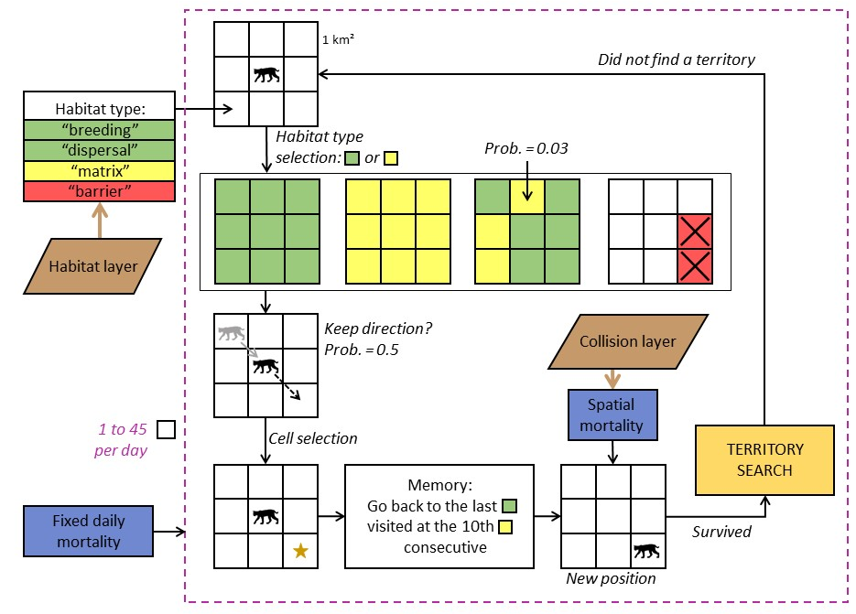
Figure S1.5: Diagram of simulated lynx dispersal movements in the lynx SE-IBM. The loop represents one step. Individuals move one cell at the time per step, up to 45 a day or until they find a territory to establish (yellow box). Individual movement is constrained by habitat types in their surroundings defined by “habitat layer” (brown box), probabilities to step into different habitat types and to keep a direction (i.e., correlated movement), and their memory. Blue boxes represent mortalities an individual suffers, a spatial one each time reaching a new location, derived from the “collision layer” (brown box) and a daily one.

Dispersing individuals arriving at a new location have a different strategy to search for a new territory to establish regarding their sex (Fig. S1.6). Females mainly look for good habitat (which represent high prey availability) while males search for breeding opportunities and seek female presence (Breitenmoser-Würsten, Zimmermann, et al., 2007b). Female dispersers need to be on a cell of habitat type “breeding”, defined by the “habitat layer”, and with enough unoccupied “breeding” habitats around their position to establish their territory. Territories can have any shapes but they must only be composed of connected cells of “breeding” habitat (search in 8-cell directions). The size of the territory females needs to define is the number of connected “breeding” cells. It represents the female territory core area (Kramer-Schadt, Revilla, & Wiegand, 2005) and depends on the population area where they are located in. We defined the size of these territories to establish as the size of the 95% kernel ranges measured in the field as kernel are computed based on the most used habitats (i.e., “breeding habitat”). When a female builds a territory in the model, the cells used are no longer available for other females. Territory size for females in the Alpine population is equal to 76 km² (Breitenmoser-Würsten et al., 2001) and to 119 km² in the Jura population (Breitenmoser-Würsten, Zimmermann, et al., 2007b). As we did not have a reliable estimate for the Vosges-Palatinian and the Black Forest populations, we assigned them the value of the Jura population due to the similarity of the habitat structure (Fig. S1.2). Once a female has established a territory, she becomes resident. If a resident male already established his territory nearby, the male includes the new resident female’s territory into his own, if he has less than three females already associated. Then, the two individuals may potentially reproduce the following year. That means, the male’s dispersal strategy to establish is female-dependent. At their new location, dispersing males check if they arrived inside the territory of a resident female available (i.e., with no male associated). If a male finds a female, he pairs with her and his territory becomes the same as the one from the female je joined. He also looks at nearby territories for up to three other available females to pair with. Males can pair with females whose territories are within the size of their maximum territories. The maximum distance between the male location and a female territory (i.e., a cell of her territory) is the radius of the 95% kernel ranges estimated for males. It is equal to 6.6 km for males in the Alpine population (95% kernel range = 137 km²; Breitenmoser-Würsten et al., 2001) and to 8.5 km for the other populations (95% kernel range = 226 km²; Breitenmoser-Würsten et al., 2007b). If there are several females available for a particular male, the closest one(s) are chosen. The male can potentially reproduce the following year with every three females. The male territory is defined by the union of all the female territories he has paired with. If a disperser cannot find a territory to create (for female) or to join (for male) at their location, it continues dispersing. If all the females a male is paired with die, the male start to disperse again in search of new available female.

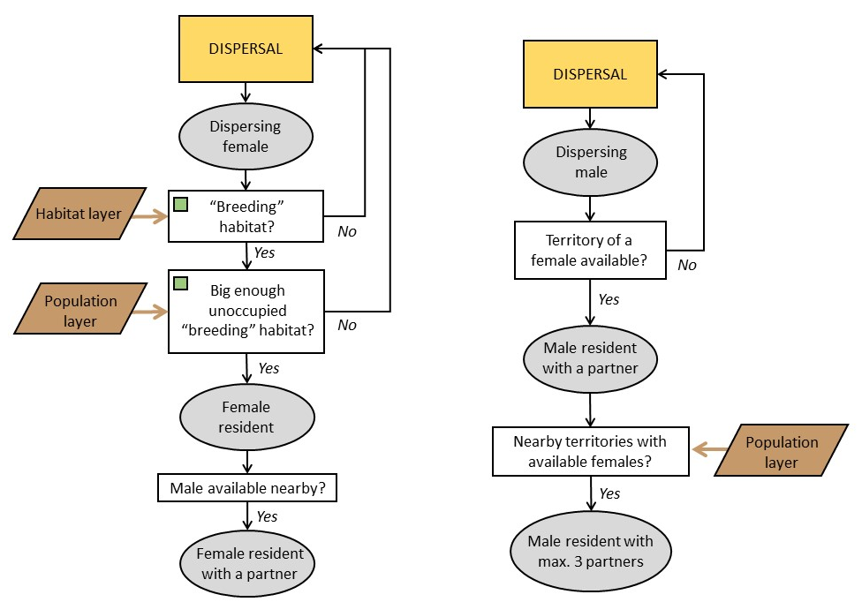
Figure S1.6: Diagram of the territory establishment in the lynx SE-IBM separated by sex. The successive grey circles represent the successive status of the individual. Females are constrained by their surrounding habitat defined by the “habitat layer” (brown box). Males are constrained by female presence. The territory sizes females need to establish in “breeding” habitat and the maximum distance to which males can look for available female residents are constrained by the population in which the individuals are located (“population layer”; brown box).

Lynx are solitary carnivores (i.e., each resident holds its own territory), except during reproduction (i.e., mating between male and female) and when females are raising their kittens (Breitenmoser et al., 1993; Stahl & Vandel, 1998). Sexually mature female residents reproduce if a sexually mature resident male occurs on their territory. Females have 0.5 chance to be sexually mature at one year old, and they are all sexually mature at two years old. Males have 0.5 chance to be sexually mature at two years old, all being sexually mature at three years old (Kvam, 1991; Kramer-Schadt, Revilla, & Wiegand, 2005; Breitenmoser-Würsten, Vandel, et al., 2007). In the wild, lynx litter size averages two kittens and can be up to four (Breitenmoser-Würsten et al., 2001; López-Bao et al., 2019). However, around 50% of lynx kittens die before reaching the age of dispersal (Breitenmoser-Würsten, Vandel, et al., 2007). We simulated that resident females up to 11 years old (“young” female in the SE-IBM model) produce one or two kittens, with a probability of 0.5 for each litter size, that will survive until becoming dispersers the following year (Henriksen et al., 2005; Kramer-Schadt, Revilla, & Wiegand, 2005). Senescence reduces litter size, therefore “old” females in the model (12 years old and older) produce zero or one kitten with an equal probability of 0.5 (Henriksen et al., 2005; Kramer-Schadt, Revilla, & Wiegand, 2005). We defined that residents die from a fixed annual mortality (i.e., baseline mortality, Table S2.1) which does not include the mortality due to vehicle collisions (i.e., spatial mortality added separately with the collision model) and illegal killing (i.e., unavailable estimates). We did not define an increase of mortality due to senescence but we set an age maximum of 20 years (Stahl & Vandel, 1998; Breitenmoser-Würsten, Vandel, et al., 2007; von Arx et al., 2017). Residents can also die from a spatial annual mortality due to vehicle collisions inside their territory. This spatial mortality is specific to each resident and corresponds to mean collision probability inside their territory. A correction factor transforms the collision probability from the “collision layer” into a yearly collision mortality.
At the end of the year, all individuals (i.e., individuals which were disperser or resident at the beginning of the year) age by one year. Individuals still dispersing will do again this same loop and the new residents will do the annual loop, as long as the simulation lasts or until they die.

The model is coded using R 4.1.0 (R Core Team, 2014). We used the package NetLogoR (Bauduin, McIntire, & Chubaty, 2019) to facilitate the IBM structure implementation in R language and the package SpaDES (Chubaty & McIntire, 2018) to schedule SE-IBM rules with different time units. We also used the packages data.table (Dowle & Srinivasan, 2019), randomcoloR (Ammar, 2019), raster (Hijmans & Van Etten, 2018), and testthat (Wickham, RStudiom, & R Core Team, 2019).

Supplementary Information 2 – Complete description of the lynx spatially-explicit individual-based model following the ODD protocol (Overview, Design concepts, and Details) developed by Grimm et al. (2006, 2010)

Overview
Purpose
The model simulates lynx population dynamics and dispersal, accounting for the impact of the road network via the risk of vehicle collisions and of the land cover to represent the lynx habitat preferences (Kramer-Schadt, Revilla, & Wiegand, 2005). Layers (i.e., maps) of collision probabilities, lynx habitats and lynx populations (Supplementary Information 1) are combined with SE-IBM rules simulating lynx dispersal (Kramer-Schadt et al., 2004, 2007) and demography (Kramer-Schadt, Revilla, & Wiegand, 2005; Kramer-Schadt et al., 2011).

Entities, state variables, and scales
The mobile entities of the model represent lynx individuals. Each simulated individual holds several characteristics:
- id: each lynx is unique and has a unique numerical identity (id);
- heading: direction of the lynx in degrees from 0 to 360 (0 is heading North) to one of its eight neighboring cells (i.e., 0º, 45º, 90º, 135º, 180º, 225º, 270º, 315º);
- location: coordinates of the lynx current position;
- previous location: lynx hold in memory the coordinates of their previous position;
- population: the population area where the individuals are born among Vosges-Palatinate, Black Forest, Jura or Alps;
- sex: male or female;
- age: numerical value to represent the lynx age. This number represents the age as for humans with zero for the first year of life, one for the second year of life, etc.;
- status: resident (i.e., established with a territory) or disperser (i.e., without a territory);
- steps: number of steps dispersing lynx have to do during the current day;
- last dispersing location: dispersing lynx hold in memory the coordinates of the last cell of habitat type “breeding” or “dispersal” they visited;
- number matrix: how many consecutive steps dispersing lynx move in “matrix” habitat;
- male id: for resident female only, the id of their male associated if they have one;
- number females: for resident male only, the number of resident females associated they have. It cannot be more than 3;
- road mortality territory: mean collision probability inside its territory;

Simulated lynx progress on a gridded study area of 1 km² resolution encompassing the four populations of interest: Vosges-Palatinian, Black Forest, Jura and Alpine, over Germany, France and Switzerland (main text, Fig. 1). The gridded study area resolution corresponds to the lynx perceptual range (Haller & Breitenmoser, 1986) and original resolution for the lynx individual-based models (Kramer-Schadt et al., 2004, 2011; Kramer-Schadt, Revilla, & Wiegand, 2005). The gridded study area holds four different variables:
- collision probability (from the “collision layer”): cells crossed by roads have an estimated probability of fatal collision with lynx, a value between zero and one. The collision probability is equal to 0 for cells with no road in it;
- habitat type (from the “habitat layer”): each cell is of one of the following habitat types: “breeding”, “dispersal”, “matrix” or “barrier”;
- individual territory: this variable holds the id of the female residents for the cells included in their territories.

Process overview and scheduling
At the beginning of each simulated year, lynx individuals are differentiated by their resident or disperser status (Fig. S1.4). First, dispersing lynx move on the gridded study area (Fig. S1.5) on a daily time step. A number of steps to move per day is generated for each dispersing lynx at the beginning of each day. All dispersers move simultaneously, one step (i.e., cell) at the time, following a correlated habitat-dependent movement influenced by the habitat type. After each step, dispersing lynx may suffer from a spatial mortality given by the collision probability at their new location divided by a correction factor to transform the value into a per step collision mortality. Then, the surviving ones search for a place where establish their territory (Fig. S1.6). Dispersing females are constrained by the habitat type in their surroundings to establish a new territory while dispersing males are constrained by the presence of available resident females for reproduction (Breitenmoser-Würsten, Zimmermann, et al., 2007b). Dispersing lynx that do not establish a territory continue to disperse during their set number of steps per day, and every day during the year until establish one. At the end of each day, lynx that dispersed suffer from a fixed daily baseline dispersal mortality. On the other hand, residents progress on a yearly time step. After the disperser movements, resident lynx may reproduce and kittens are born. Then, residents may die from a fixed annual baseline mortality and from a spatial annual mortality, the latter being defined by the mean collision probability inside their territories multiplied by a correction factor to transform the value into a yearly collision mortality. All these happen once in the year. At the end of a year, all lynx age are incremented by one and their status is updated if applicable.
Simulated lynx id, population, and sex variables do not change during a simulation. Their heading, location, previous location, last dispersing location, number matrix, male id, number females and road mortality territory may change at every dispersal step. The steps variable is updated each day, and age and status are updated once a year. There is no modeling of the landscape during the simulation, therefore the collision probability and habitat type are constant during one simulation. However, the territory id may change at every step (i.e., each time there is a new territory created).

Design concepts
Basic principles
Our lynx SE-IBM is an assemblage of four components: three spatial layers and an existing individual-based model (Kramer-Schadt et al., 2004, 2007, 2011; Kramer-Schadt, Revilla, & Wiegand, 2005) parameterized with field data and inverse model fitting (main text, Fig. 2 and Supplementary Information 3). The collision probability layer and the habitat type layer are output maps from a collision model and a habitat model (Supplementary Information 1). The “population layer” was generated using presence data and estimated number of lynx (Supplementary Information 1).

Emergence
Simulated males and females follow the same rules, except for the territory establishment where females are constrained by the habitat and males by the presence of females (Breitenmoser-Würsten, Zimmermann, et al., 2007b). In an area with few individuals, females have many possibilities of empty land to establish. On the other hand, males will have to move further to find one of the few females available, inducing longer dispersal movement and higher chances of dying. However, in a very dense area, this can be reverse. Females will have to move further to find free land whereas males, if they are not too numerous, may move less as they may have many females around them to pair with. If there are many males, all females may be already taken, inducing again longer dispersal for the males.
To mate, residents are constrained by the presence of a partner on their territory and both individuals need to be in age of reproduction. The presence of a suitable partner depends on their past dispersal movement and territory search, and if they could establish a new territory or not. Reproduction success is therefore stochastic, as well as the number of kittens. All this will modify the number of new individuals in the population.
Residents and dispersers are subject to a fixed baseline and spatial mortality. Both mortalities are stochastic and the spatial one depends on the location of the individuals (i.e., collision probability at their location). The location of the individuals depends on their current or past dispersal movement that depends on the habitat type. All this will modify the number of individuals dying each year.

Adaptation
There is no adaptation in the SE-IBM (e.g., no density-dependent rules). All individuals follow the same behavioral rules dependent on their inner and environmental characteristics.

Objectives
Simulated lynx do not have adaptive traits and they do not have a final goal to reach. They take decisions at each time step based only their current characteristics and their environment to fulfill an immediate goal (e.g., where to move next).

Learning
Simulated lynx try to minimize their time spent in poor habitat quality. When they step into “matrix” habitat, they store the position they just left (i.e., their last position in good habitat so either in “breeding” or “dispersing” habitat) and start counting how many consecutive steps into “matrix” they do. At the 10th step, if the chosen cell is still located into “matrix”, simulated lynx will use their memory to find and move back to their last location of good habitat.

Prediction
Simulated lynx cannot predict the future nor have a global view of the study area. Both residents and dispersers sense the current state of their environment and population in their immediate surroundings and react to this information only. For example, dispersing lynx move, making decisions based only on their immediate surroundings. They cannot anticipate their path nor have a global view of their environment to make advantageous decisions for the long term (e.g., they cannot find a better territory and/or more quickly).

Sensing
Simulated lynx can sense the habitat types and the individual territories of their surroundings. Dispersers establishing a territory and trying to find a partner can sense other individuals: it knows who hold nearby territories and the characteristics of these individuals, such as their sex and the availability to pair with.

Interaction
There is a tacit competition between dispersing individuals during the territory search. Dispersers evaluate their surroundings before establishing one at the time (in a random order each time). The first female in the list looking for a territory has therefore more chance to find empty space to establish than the last female. Similarly, the first male in the list looking for an available female to join has more chance to find a partner than the last male.
Residents also interact with each other for reproduction. If a male and a female resident in age of reproduction are on the same territory, they may reproduce and produce new individuals. However, this interaction does not affect any of the individuals (i.e., a reproduction event does not change the characteristics of the concerned individuals).

Stochasticity
The model involves several stochastic processes. Regarding demography, both reproduction (i.e., the reproduction event itself and the number of kittens) and mortality (both fixed baseline and spatial for both residents and dispersers) are defined with probabilities and therefore outcomes vary between individuals. During dispersal, the choice of the habitat type to select when there is a mix of “breeding/dispersal” and “matrix” habitats in the lynx surroundings depends on the probability to step into “matrix”. Then, there is also stochasticity in the choice of the next location within the selected habitat type, as the choice to follow a correlated movement or not are defined by probabilities, as well as the choice of the next location among those available if the movement is not correlated. Finally, the number of steps dispersing simulated lynx must move during a day is sampled from a probability distribution and so, the outcomes are not the same for all individuals all the time.

Collectives
When a resident male finds one or several available resident females, he may pair and reproduce with them. Every year, the pairs persist unless one of the lynx dies and therefore frees the other one to find another partner.
Individuals belong to populations. The two rules different between populations are the size of the territory females have to reach and the maximum size of territory males can hold (i.e., how far can they look for females). Other than that, no rule is defined at the population level and the population affiliation does not affect the individual progress. Individual progress according to their own characteristics.

Observation
The state of all alive simulated individuals (i.e., their location and characteristics) and of the individual territory map are available at the end of each yearly time step. All disperser movements are also recorded on a single map over the whole simulation time. Events changing the demography are saved each year: which individuals died and how (i.e., from the fixed baseline mortality or from collision), which individuals reproduce, who are the kittens, and which individuals became residents.

Details
Initialization
At the beginning of the simulation, a grid covering the whole study area (main text, Fig. 1) with a resolution of 1 km² is created. The values from the “habitat layer” and the “collision layer” are transferred to the gridded study area variables habitat type and collision probability. The variable individual territory is set to missing value (NA) everywhere. Habitat type on the borders of the grid are set to “barrier” so that individuals “bounce” on the borders. We assumed that these individuals would have had a hard time to go beyond the borders of the study area as we encompassed the main populations and patches of good habitats and therefore would be unlikely to leave the study area.
Using the “population layer”, a lynx population is created with unique id for each individual, location, population, as well with a sex and age (when known from field data) for some individuals. A simulated individual cannot start in “matrix” or “barrier” habitats. Therefore, if some individuals’ location are located in these habitats, they are relocated to the closest cell of “breeding” or “dispersal” habitat. At the start of the simulation, individuals cannot have a previous location or a last dispersing location, so we used their current location for these two variables. For individuals with unknown sex or age (no field data), a random sex (male or female with ratio 1:1) and age (between 2 and 15) is randomly given. A random heading (i.e., initial direction) is given to each individual, between 0° and 360°. At the start, all individuals have a disperser status, 0 steps to do, 0 steps done in “matrix” (number matrix) and 0 for road mortality territory. As all individuals are dispersers, no couples are made so male id for the females are set to NA and the number females for males are set to 0 (Table S2.1).
The parameter values used in the SE-IBM to represent the dynamics and dispersal of the Eurasian lynx in our study area (main text, Fig. 1) are provided in Table S2.1.

Table S2.1: Parameter values used in the SE-IBM
Parameter | Explanation | Value | Reference
endTime | Number of years to simulate the lynx populations. | 50 | By default
pRepro | Probability of mating for a resident female which has a resident male associated on her territory when they are both in age of reproduction. | 0.95 | Model calibration (see Supplementary Information 3)
nKittyYoungF | Number of kittens that survive until the age of dispersal when the female is considered “young” (maxAgeYoungF parameter). | 1 or 2 (with equal probability for each value) | (Breitenmoser-Würsten et al., 2001; Henriksen et al., 2005; Kramer-Schadt, Revilla, & Wiegand, 2005; Breitenmoser-Würsten, Vandel, et al., 2007; López-Bao et al., 2019)
nKittyOldF | Number of kittens that survive until the age of dispersal when the female is considered “old” (maxAgeYoungF parameter). | 0 or 1 (with equal probability for each value) | (Breitenmoser-Würsten et al., 2001; Henriksen et al., 2005; Kramer-Schadt, Revilla, & Wiegand, 2005; Breitenmoser-Würsten, Vandel, et al., 2007)
maxAgeYoungF | Age maximum for a female to be considered “young”. | 11 | (Henriksen et al., 2005)
minAgeReproF | Age minimum at which all resident females can reproduce (i.e., are sexually mature). One year younger, only half of the females are mature. | 2 (3rd year of life) | (Kvam, 1991; Henriksen et al., 2005; Breitenmoser-Würsten, Vandel, et al., 2007)
minAgeReproM | Age minimum at which all resident males can reproduce (i.e., are sexually mature). One year younger, only half of the males are mature. | 3 (4th year of life) | (Kvam, 1991)
pMortResAlps | Fixed annual baseline probability of mortality for resident lynx (without the risk of collisions included) of the Alpine population. | 0.15 | Model calibration (see Supplementary Information 3)
pMortResJura | Fixed annual baseline probability of mortality for resident lynx (without the risk of collisions included) of the Jura population. | 0.15 | Model calibration (see Supplementary Information 3)
pMortResVosgesPalatinate | Fixed annual baseline probability of mortality for resident lynx (without the risk of collisions included) of the Vosges-Palatinian population. | 0.15 | Same value as pMortResJura, see model calibration (Supplementary Information 3)
pMortResBlackForest | Fixed annual baseline probability of mortality for resident lynx (without the risk of collisions included) of the Black Forest population. | 0.15 | Same value as pMortResJura, see model calibration (Supplementary Information 3)
corrFactorRes | Correction factor for road mortality risk for residents. This factor multiplies the road mortality territory value to transform it into a yearly collision mortality. | 3.9 | Model calibration (see Supplementary Information 3)
corrFactorDisp | Correction factor for road mortality risk for dispersers. This factor divides the collision probability of from the “collision layer” to transform the value into a per step collision mortality. | 170 | Model calibration (see Supplementary Information 3)
ageMax | Age maximum a lynx can reach. When reaching this age, lynx die from natural causes. | 20 | (von Arx et al., 2017)
xPs | Exponent value of the power function to define the daily step distribution. This distribution is used to sample a number of steps per day to move for dispersing lynx. | 11 | (Kramer-Schadt et al., 2004)
sMaxPs | Maximum number of steps dispersing lynx can do in one day. | 45 | (Kramer-Schadt et al., 2004)
pMat | Probability of stepping into “matrix” cells. This probability is multiplied by the number of “matrix” cells available for a dispersing lynx to define its probability to choose this habitat type for its next location. | 0.03 | (Kramer-Schadt et al., 2004)
pCorr | Movement correlation probability for dispersal movement. | 0.5 | (Kramer-Schadt et al., 2004)
pMortDispAlps | Fixed daily baseline probability of mortality for dispersing lynx (without the risk of collisions included) of the Alpine population. | 0.0007 | Model calibration (see Supplementary Information 3)
pMortDispJura | Fixed daily baseline probability of mortality for dispersing lynx (without the risk of collisions included) of the Jura population. | 0.0009 | Model calibration (see Supplementary Information 3)
pMortDispVosgesPalatinate | Fixed daily baseline probability of mortality for dispersing lynx (without the risk of collisions included) of the Vosges-Palatinian population. | 0.0009 | Same value as pMortDispJura, see model calibration (Supplementary Information 3)
pMortDispBlackForest | Fixed daily baseline probability of mortality for dispersing lynx (without the risk of collisions included) of the Black Forest population. | 0.0009 | Same value as pMortDispJura, see model calibration (Supplementary Information 3)
nMatMax | Maximum number of consecutive steps a dispersing lynx can do into “matrix” habitat. After this number of steps, disperser can use its memory to find and move in the last good habitat visited (“breeding” or “dispersal” habitat). | 9 | (Kramer-Schadt et al., 2004)
coreTerrSizeFAlps | Territory size (in km²) females located in the Alpine population need to reach. | 76 | (Breitenmoser-Würsten et al., 2001)
coreTerrSizeFJura | Territory size (in km²) females located in the Jura population need to reach. | 119 | (Breitenmoser-Würsten, Zimmermann, et al., 2007b)
coreTerrSizeFBF | Territory size (in km²) females located in the Black Forest population need to reach. | 119 | (Breitenmoser-Würsten, Zimmermann, et al., 2007b)
coreTerrSizeFVP | Territory size (in km²) females located in the Vosges-Palatinian population need to reach. | 119 | (Breitenmoser-Würsten, Zimmermann, et al., 2007b)
terrSizeMAlps | Maximum territory size (in km²) males located in the Alpine population can reach. | 137 | (Breitenmoser-Würsten et al., 2001)
terrSizeMJura | Maximum territory size (in km²) males located in the Jura population can reach. | 226 | (Breitenmoser-Würsten, Zimmermann, et al., 2007b)
terrSizeMBF | Maximum territory size (in km²) males located in the Black Forest population can reach. | 226 | (Breitenmoser-Würsten, Zimmermann, et al., 2007b)
terrSizeMVP | Maximum territory size (in km²) males located in the Vosges-Palatinian population can reach. | 226 | (Breitenmoser-Würsten, Zimmermann, et al., 2007b)
nFem | Maximum number of resident females a resident male can pair with and potentially reproduce with. | 3 | (Kramer-Schadt, Revilla, & Wiegand, 2005)

Input data
See Supplementary Information 1.

Submodels
Dispersal: A number of steps to do during the day is sampled every day from the distribution defined by Kramer-Schadt et al. (2004), one per dispersing individual. Dispersers move one cell per step, into one of their eight neighboring cell or their current cell (i.e., so a total of nine potential cells for their next location). First, there is a selection of the habitat type each disperser chooses for its next location. Among those nine cells, all cells of “barrier” type are removed from the potential choices. As individuals cannot be on “barrier” habitat, it cannot happen that all nine cells are “barrier”. For a dispersing individual, if all his cells are of “breeding” or “dispersal” type, this type (“breeding/dispersal” without distinction between the two) is selected. If all his cells are of “matrix” (i.e., habitat not favorable for lynx), this type is selected. If the cells are a mix of “breeding/dispersal” and “matrix”, there is a Bernoulli trial of mean 0.03 (Table S2.1) times the number of “matrix” cells among the nine to select the “matrix” habitat type.
Second, there is the choice of the cell for the next location, among all cells of the selected habitat type. If there is only one cell of the selected type, the disperser goes on this one (for example, if the selected cell type is “breeding/dispersal” and there is only one cell of “breeding/dispersal” habitat, all other cells being “matrix” or “barrier”, therefore the only cell of “breeding/dispersal” is selected). Otherwise, there is a choice either random or governed by a correlation movement to select the cell. The first step of the day is never correlated, otherwise there is a Bernoulli trial of mean 0.5 (Table S2.1) to determine if the movement is correlated for each individual for each step. If there is no correlation of the movement, the choice for the cell is done with an equal probability for all the cells of the selected type. If the movement is correlated, the rotating angle between the individual’s heading and each cell of the selected type is calculated. There is a preference for the cell minimizing this rotating angle. If the cell that the individual is on is of the selected habitat type (i.e., this cell can be selected for the individual’s next step which will make the lynx stay at its current location), the preference for this cell is equal to the preference for the cells inducing a rotation of +/- 90 degrees, to favor a forward movement. The selected cell is the one with the highest preference (i.e., smallest rotation movement).
Third, if the selected cell is of “matrix” type, the individuals check how many consecutive steps they have done in “matrix” habitat (number matrix). If a disperser has already step nine consecutive times (Table S2.1) in “matrix” and this 10th consecutive step is in “matrix” too, it used its memory and select, for its next location, the last visited cell of good habitat (“breeding” or “dispersal”), stored in his memory (last dispersing location) (Kramer-Schadt et al., 2004).
Finally, all dispersers rotate towards their selected cell and move to the center of it. They update their previous location with the coordinates of the cell they were before moving. If their new location is of type “breeding” or “dispersal”, this location is stored in their memory for the last dispersing location, and their number matrix is reset to zero. If their new location is of type “matrix”, their number matrix increments of one.
Now, disperser may be also subject to spatial mortality. There is a Bernoulli trial for each disperser with mean equal to the collision probability value of their new location divided by a correction factor (Table S2.1). Dispersers that do not die from spatial mortality search for a new home range to establish (searchTerritory sub-model).
The dispersal movement is done until all dispersing individuals have reached their number of steps to do during the day, or they have established a territory and are now resident, or they died from spatial mortality. At the end of the day, all individuals that were dispersers at the beginning of the year (even the ones that established a territory during the day or previous day) may die from a fixed daily baseline mortality using a Bernoulli trial for each individual. A daily spatial mortality is also applied to individuals which dispersed during the year but already found a territory during previous days. As movements inside territories are not simulated but they were not considered as resident at the beginning of the year, a per step or an annual spatial mortality cannot be applied. Their daily spatial mortality is then calculated as their spatial mortality with their resident status divided by 365. If some of the individuals dying established a territory during this day, there is an update of their characteristics similarly as the death of resident individuals (mortality submodel).
At the beginning of the simulation, all initial individuals were created as dispersers to let simulated individuals establish their initial territories. Individuals needs some time to do so, therefore we did not apply any mortality (daily baseline nor spatial) during the first year of simulation to allow dispersers to establish their territories.

SearchTerritory: Dispersing individuals arriving at a new location search for a territory to establish, one at the time, and females first (i.e., male establishment depending on female territories). One at the time, in a random order each time, females evaluate their surroundings to establish their territory. Females needs to be on a cell of “breeding” type that is not already included in any territory to start creating their own. Then, they need to have enough empty contiguous cells of “breeding” habitat (search in 8-cell directions) to create a big enough territory (Table S2.1). When enough empty contiguous cells of “breeding” habitat are present, females establish their territory and becomes resident. Otherwise, they stay disperser and keep dispersing. After a female establishes her territory, all the cells of this territory become occupied and are not available anymore for the other females. The female id is given to the individual territory study area variable for all cells in her territory. The mean collision probability of the territory is calculated and given to the female for her road mortality territory. Then, the female checks if there is a resident male around. If there is a male not further than the radius of the maximum territory size for the male (Table S2.1) and he has less than three females associated, she pairs with him. Then, she obtains the male id for her male id and the number females of the male increments of one.
After all dispersing females tried to establish, dispersing males try to disperse of their own, one at the time in a random order each time. Each male checks if the cell they are currently on is located inside the territory of an available female (i.e., without male associated yet). If there is one, the male pairs with this female and becomes resident. His territory is the same one as the female and its number females is set to one. The female obtains the male id for her male id variables. Then, the male also looks if there are other nearby available females to pair with, as far as the radius of its maximum territory size (Table S2.1). He can pair with up to three available females. The male territory represents the union of all the female territory with which he paired with. His road mortality territory is the mean value of the road mortality territory of all the females he paired with.

Reproduction: A female resident in age of reproduction (one or two years old, see Table S2.1) with a resident male associated, also in age of reproduction (two or three years old, see Table S2.1), may reproduce with a Bernoulli trial (Table S2.1) and have offspring. If the couple reproduces, the female can produce one or two kittens with equal probability (Table S2.1) if she is “young” (11 years old or younger; Table S2.1) or zero or one kitten with equal probability if she is “old” (12 years old or older; Table S2.1). Kittens obtain a unique id. The sex of the kittens is randomly chosen between male and female with ratio 1:1 (Table S2.1). Their location, heading and last dispersing location are the ones from their mother. Their previous location is NA. Their population is not the one of their parents but the one of the territory where they are born. Their age is 0, their status is resident (i.e., they stay with their mother and cannot disperse at this age), their steps and number matrix are zero, their male id is NA, and their number females and road mortality territory are zero.

Mortality: Resident individuals may die from a fixed baseline annual mortality (Table S2.1) and a spatial mortality using a Bernoulli trial. We did not simulate an effect of senescence but we set an age maximum (20 years; Stahl & Vandel, 1998; Breitenmoser-Würsten, Vandel, et al., 2007; von Arx et al., 2017) and all individuals reaching this age die from a non-collision source (i.e., old lynx mortality is not included in the collision mortality). Resident individuals may also die from spatial mortality, the mortality rate for female residents is the mean collision probability of the cells inside of their territory (road mortality territory) multiplied by a correction factor (Table S2.1). For male residents, spatial mortality rate is the mean road mortality territory of all his paired females multiplied by the same correction factor (Table S2.1).
When a resident female dies, her territory disappears (i.e., her id is removed from the individual territory study area variable) and the local male resident loses one female. If this male did not have other females, he becomes disperser again to look for new available female resident as male home ranges are adjusted to mate availability (Breitenmoser-Würsten, Zimmermann, et al., 2007b). If the dead female had kittens during the year, they all die too. When a male resident dies, its paired females become available to reproduce with other males.

Demography: All individuals’ age increment of one. The status of the offspring of the year changes from resident to disperser.

Supplementary Information 3 – Calibration of the parameters, sensitivity analysis and model validation

Calibration of the parameters
We calibrated the lynx SE-IBM using a pattern-oriented modeling (Grimm & Railsback, 2012; Gallagher et al., 2021) in a two-phase process. To better adapt the model to our study area and simulated lynx populations, we (re)estimated the following 7 parameters:
- pMortResAlps / pMortDispAlps / pMortResJura / pMortDispJura: Fixed annual baseline mortalities (i.e., probabilities) applied to resident / dispersing lynx, without the risk of collisions included, for the Alpine and the Jura populations. These parameters do not exactly represent the mortality rates for lynx when omitting collision mortality observed in the field as the mortality due to old age in our model is additive to these estimated baseline probabilities. For the mortality probabilities for the Vosges-Palatinian and the Black Forest populations, we used those of the Jura population and they were not calibrated per se;
- corrFactorRes: Correction factor for road mortality risk for residents. This factor multiplies the road mortality territory to transform the value into a yearly collision mortality;
- corrFactorDisp: Correction factor for road mortality risk for dispersers. This factor divides the collision probability from the “collision layer” to transform the value into a per step collision mortality;
- pRepro: Probability of mating for a resident female which has a resident male associated on the same territory, when they are both in age of reproduction. This parameter is different than the probability of reproducing observed in the field, detected by the presence of kitten, as, in our model, old female can mate but produce 0 young because of her age.
For the first phase of calibration, we sampled one value for each parameter to calibrate among wide ranges of values (Table S3.1). We defined 50 calibration scenarios by sampling a value within the range for each parameter for each scenario. We ran 15 replicates of each calibration scenario. We ran the lynx SE-IBM forecasting the populations over 50 years and we used a different initial population (Supplementary Information 1) at each replicate within each scenario to avoid bias due to initial locations of simulated individuals. We did not simulate any mortality during the first year of simulation to allow dispersing individuals to find a territory, if they can, without dying while doing so. From simulation outputs, we computed 13 patterns for each scenario, taking the mean value over the 15 replicates. Patterns were population emergent properties from simulations that we could compare to reference values. We defined a burn-in phase of 2 years after the start of the simulation to let the population settle down so that only outputs from the 3rd year of simulation were used to compute patterns. Reference values for the patterns were extracted from literature or computed from field data. In order to calibrate the model, we looked for the calibration scenarios (i.e., and their associated parameter values) which minimized the differences between the pattern values extracted from their simulation outputs and the pattern values from external sources. The patterns we tried to match with their values and 95% confidence intervals from literature or data were:
- rAllRes_Alps = 0.24 [0.08;0.57] / rAllDisp_Alps = 0.24 [0.15;0.38]: Annual mortality rates observed for resident / dispersing individuals from all causes of mortality (i.e., including collisions) for the Alpine population (Premier et al., 2025).
- rCollRes_Alps = 0.02 [0;0.059] / rCollDisp_Alps = 0.077 [0;0.211]: Annual mortality rates observed for resident / dispersing individuals from collisions with vehicles for the Alpine population (Premier et al., 2025).
- nCollAlps = 2 [0;3]: Mean annual number of fatal collisions observed for the Alpine population (data for 2017-2021: OFB Réseau Loup-Lynx and KORA).
- rAllRes_Jura = 0.17 [0.1;0.29] / rAllDisp_Jura = 0.35 [0.16;0.65]: Annual mortality rates for resident / dispersing individuals from all causes of mortality (i.e., including collisions) observed for the Jura population (Premier et al., 2025).
- rCollRes_Jura = 0.034 [0;0.08] / rCollDisp_Jura = 0.067 [0;0.185]: Annual mortality rates for resident / dispersing individuals from collisions with vehicles observed for the Jura population (Premier et al., 2025).
- nCollJura = 6 [3;9]: Mean annual number of fatal collisions observed for the Jura population (data for 2017-2021; OFB, Réseau Loup-Lynx and KORA).
- rRepro = 0.81: Observed proportion of resident females reproducing (Breitenmoser-Würsten, Vandel, et al., 2007a; López-Bao et al., 2019).
- distDispAlps = 26 [15;36] / distDispJura = 63 [39;87]: Mean dispersal distance in kilometers, computed as a straight line, between the natal territory and the new established territory after dispersal observed for the Alpine and the Jura population (Zimmermann, Breitenmoser-Würsten, & Breitenmoser, 2005).
We removed from the calibration process the calibration of the parameter pRepro and its associated pattern rRepro as quick tests showed that a pRepro of 0.95 produced a stable mean of rRepro equal on average to 0.79 [0.78;0.80], independently from the other parameter values. Among the 50 calibration scenarios, none produced patterns for which the mean values computed from the simulation outputs fall into the 95% confidence intervals of the reference values for all patterns simultaneously. We therefore omitted the patterns about dispersal distances for this step (distDispAlps and distDispJura) as we chose to focus on the mortality process. Without these two patterns about dispersal distances, 2 out 50 scenarios produced patterns within the confidence intervals for the 10 remaining patterns (Table S3.2).
For the second phase, we fined tuned the calibration of the 6 parameters to calibrate (i.e., still omitting rRepro). We explored a narrower range of values for each parameter, which included the parameter values sampled in the two scenarios that resulted in the best calibrations in the first phase (Table S3.1). Similarly as in the first phase, we ran 50 new calibration scenarios (with 15 replicates each time) in the same conditions, and computed the same patterns. Again, none of the scenarios could satisfy the 13 patterns simultaneously. When removing the reproduction (i.e., not relevant) and the dispersal distances (i.e., too constraining), 25 scenarios produced patterns with their mean values falling within the confidence intervals of the reference values for the 10 remaining patterns. We finally selected, among those 25, the scenario which produced patterns with mean values the closest to the 13 pattern values simultaneously (Table S3.2). The parameter values sampled for this scenario (Table S3.1) were the ones selected and used to run the simulations to produce the results presented in the main text.

Table S3.1: Value tested or selected for the parameters to be calibrated. “Phase 1” and “Phase 2” present the range of the values tested for each parameter for the two phases of the calibration. One value was randomly sampled within each range for each calibration scenario. “Phase 1. Best 1” and “Phase 1. Best 2” are the values from the best two scenarios of the first phase of calibration. “Selected” presents the selected values at the end of the phase 2 of the calibration process.
 | pMortResAlps | pMortDispAlps | pMortResJura | pMortDispJura | corrFactorRes | corrFactorDisp
Phase 1 | [0.05;0.25] | [0.0001;0.002] | [0.05;0.25] | [0.0001;0.002] | [1;6] | [50;300]
Phase 1. Best 1 | 0.15 | 0.0007 | 0.19 | 0.0008 | 3.5 | 175
Phase 1. Best 2 | 0.15 | 0.001 | 0.12 | 0.0007 | 3.5 | 175
Phase 2 | [0.13;0.17] | [0.0005;0.0012] | [0.10;0.21] | [0.0005;0.001] | [3;4] | [125;225]
Selected | 0.15 | 0.0007 | 0.15 | 0.0009 | 3.9 | 170

Table S3.2: Patterns values. “Reference” are values (mean and 95% confidence intervals) extracted from the literature or field data. “Phase 1. Best 1” and “Phase 1. Best 2” are the pattern values (mean and 95% confidence intervals over the 15 replicates) computed with the simulation outputs from the scenarios which were the best ones from the first phase of the calibration process. “Selected” presents the pattern values (mean and 95% confidence intervals over the 15 replicates) computed with the simulation outputs from the best calibration scenario selected in the second phase of the calibration process.
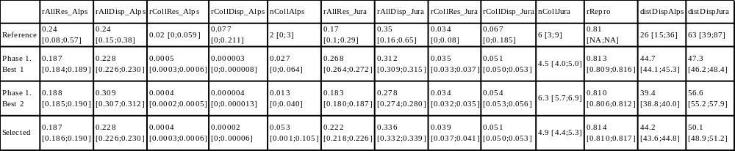

Sensitivity analysis
The second phase of the calibration was used to perform the sensitivity analysis. Multiple values were tested for each parameter, values smaller and larger than the ones selected. We compared the percentage of variation of the parameter values used in the second phase of the calibration (Fig. S3.1) with the percentage of variation on the main result of the simulation, the population growth rates (Fig. S3.2).

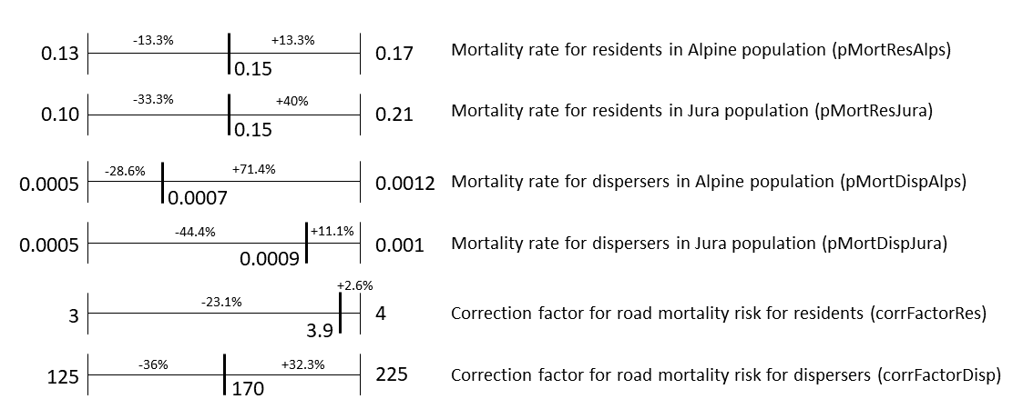
Figure S3.1: Range of values tested during the second phase of calibration for each calibrated parameter. The value indicated within the range of each parameter was the selected one with the best calibration scenario. Percentages noted are the difference between the selected value and the minimum and maximum values of the range for each parameter.

a)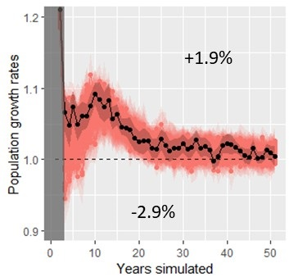 b)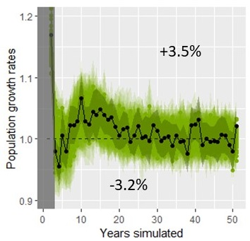
c)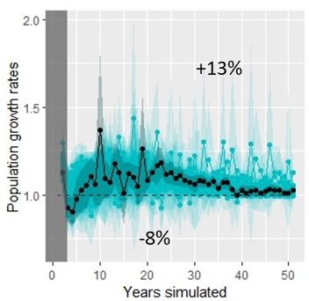 d)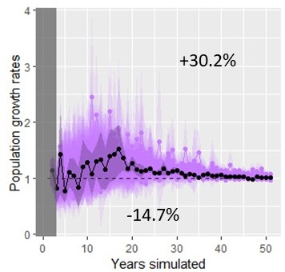
Figure S3.2: Annual rates of increase over the simulated years for each population (a) Alpine, b) Jura, c) Vosges-Palatinian, d) Black Forest). The grey area represents the 2-year burn-in phase at the beginning of the simulation. Overlaid colored points are mean over the 15 replicates and overlaid colored envelopes are 95% confidence intervals from the 15 replicates, for each of the 50 calibration scenarios from the second calibration phase. The black point and darker colored envelope represent the mean and 95 % confidence interval from the 15 replicates for the best calibration scenario selected during this second calibration phase. The dashed line represents a stabilization of the population (growth rate equals to 1). The percentage noted above the lines is the mean over all the years of the differences between the values for the selected scenario (means over the 15 replicates) and the maximum values of each year (maximum means calculated over the 15 replicates for the particular scenario this year). The percentage noted below is the same value but calculated with the minimum values each year.

The growth rates calculated for the Alpine and the Jura population were not sensitive to the different parameter estimates as the variations in parameter values were much larger than those of the result values. Parameters varied from -13.3% down to -44.4% and from +2.6% up to 40% in values (Fig. S3.1), whereas the growth rates for these two populations varied on average from -2.9% up to +1.9% for the Alpine population and from -3.2% up to +3.5% for the Jura population (Fig. S3.2). The variation in the growth rates for the Vosges-Palatinian population were a little larger (from -8% up to +13%) (Fig. S3.2) but still smaller than most of the variations of the parameters (Fig. S3.1). The growth rates for the Black Forest population on the other hand seemed sensitive to the model parameters with variations from -14.7% up to +30.2% (Fig. S3.2). Results concerning this population were therefore less robust to interpretation. However, this population had very large confidence intervals regarding it growth rates compared to the other populations which made the confidence in the population trend already less precise for interpretation (main text, Fig. 3). The Vosges-Palatinian population and especially the Black Forest one had very few starting individuals (i.e., more prone to stochasticity) and data from the literature, making the model harder to calibrate regarding these populations and therefore less reliable to forecast their future. In comparison, the Alpine and Jura populations had more starting individuals and data from the literature to calibrate the model and therefore showed a stronger confidence and precision in the results.

Model validation
Among the 13 patterns used for calibration, the selected set of parameters (i.e., calibration scenario selected during the second phase) produced simulation results for which the pattern values of 11 of them fell into the 95% confidence intervals of the reference values (Table S3.2). However, the confidence intervals for the pattern simulated values were extremely narrow (Tables S3.2 and S3.3) compared to those of the reference values. Therefore, model stochasticity did not seem very important. The reproduction rate reference value did not have a confidence interval available but the simulated value was very close and the reference value was inside the 95% confidence interval of the simulations. We completed this validation phase looking at the number of simulated collisions for the first few years with the concurrent field data. As the model was parameterized with 2017 data, we compared the simulated collisions for the Alpine and Jura populations for the first five years with the recorded collisions in these two populations for 2017 until 2021 (Table. S3.3). From the calibration pattern results and this collision validation, we were very confident in the selected parameter values regarding the demographic parameters (i.e., mortality and reproduction rates), and especially for the Jura population.
The simulated collisions data matched less the field data for the Alpine, although the number of collisions were very low in this population (Table S3.3). Also, the only discrepancy between the reference values and the simulated results for the calibration patterns (Table S3.2) were for the dispersal distances for the Alpine population. The individuals seemed to have dispersed further in the simulations than computed from the field data. The model may need more attention on the interpretation for the Alpine population as the mortality may be slightly under-estimated and dispersal distances slightly over-estimated. Both could be linked as individuals could move further away as they were dying less doing so.

Table S3.3: Number of vehicle collisions with adult or subadult lynx. Collisions with juveniles were not included in the recorded data as the SE-IBM did not simulate movement for the lynx in their first year of life and therefore cannot reproduce juvenile collisions. “Recorded” were real collisions recorded in the field. “Simulated” were collisions simulated with the 100 simulation replicates using the parameter values selected (mean and 95% confidence interval over the 100 replicates).
 | 2017 | 2018 | 2019 | 2020 | 2021
Number of collisions recorded for the Jura population | 6 | 10 | 4 | 5 | 5
Number of collisions simulated for the Jura population | 5.7 [5.1;6.2] | 5.1 [4.6;5.6] | 5.5 [5.1;5.9] | 5.3 [4.8;5.8] | 4.8 [4.4;5.2]
Number of collisions recorded for the Alpine population | 2 | 0 | 3 | 1 | 3
Number of collisions simulated for the Jura population | 0.01 [0;0.03] | 0.03 [0;0.06] | 0.03 [0;0.06] | 0.01 [0;0.03] | 0.04 [0;0.08]

Supplementary Information 4 – Model validation using telemetry data

We performed a qualitative validation of the lynx model predictions using tracks from collared female residents. The map below (Fig. S4.1) shows the simulated territory occupancy with darker red colors representing areas most often occupied by female territories across simulation replicates and blue the least occupied (main text, Fig. 5). We overlaid GPS and VHF paths from collared female residents on the map. Data in the Vosges-Palatinate consist in two females in the Palatinate Forest (Germany) and one in the Vosges Mountains (France) (locations recorded in 2017-2018; Scheid et al., 2021). Data in the Jura represent four females in France and 13 in Switzerland (locations recorded in 1988-1998; Breitenmoser-Würsten, Zimmermann, et al., 2007b). Data in the Alps (Switzerland) represent 16 females (locations recorded in 1997-2000; Breitenmoser-Würsten et al., 2001). We show the full study area and four zoomed areas on the telemetry locations. Overall, the realized movements and territory emergence inferred from field data were coherent with the frequencies across simulation replicates of the territories defined by simulated lynx. Very few telemetry locations fall in white and grey cells (i.e., non-breeding habitat and breeding habitat cells never selected as part of a female territory across the 100 simulation replicates respectively) and most of the recorded tracks were located in cells with a high frequency of territory occupancy across the simulation replicates.

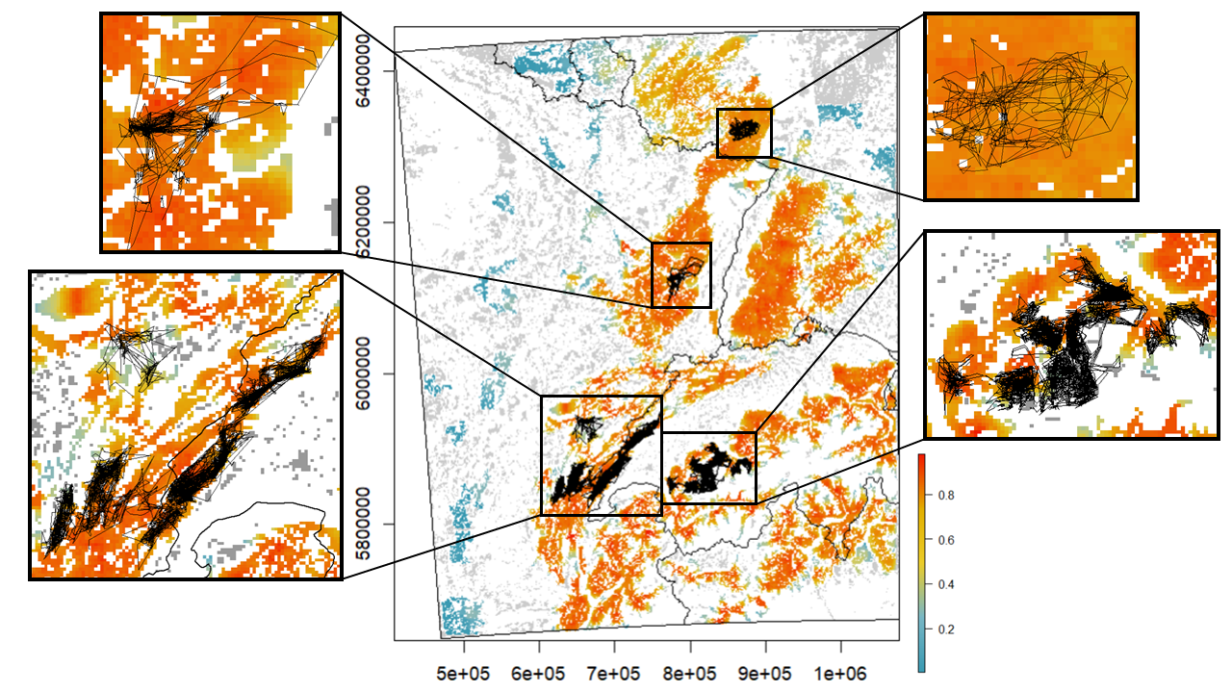
Figure S4.1: Occupancy by female territories over the study area at the last year of simulation. Values between above zero and one (color scale blue-yellow-red) are mean occupancy probability per cell of 1 km² over 100 replicates (e.g., a cell equal to 1 means the cell was included in a female territory, at the 50th year of simulation, in all 100 simulation replicates). Grey cells are “breeding habitats” never included in a female territory across all replicates (equal to zero). White cells are cells of a habitat type different than “breeding habitat” and therefore could never be included in a female territory. GPS and VHF recorded paths for female residents are overlaid as thin black lines. A zoom of different areas is presented on the sides of the central map.

References (Supplementary Information)
Ammar, R. (2019). randomcoloR: Generate Attractive Random Colors.
Basille, M., Van Moorter, B., Herfindal, I., Martin, J., Linnell, J. D. C., Odden, J., Andersen, R., & Gaillard, J. M. (2013). Selecting habitat to survive: the impact of road density on survival in a large carnivore. PLoS One 8, e65493.
Bauduin, S., McIntire, E. J. B., & Chubaty, A. M. (2019). NetLogoR: a package to build and run spatially explicit agent‐based models in R. Ecography (Cop.). 42, 1841–1849.
Breitenmoser-Würsten, C., Vandel, J.-M., Zimmermann, F., & Breitenmoser, U. (2007a). Demography of lynx Lynx lynx in the Jura Mountains. Wildlife Biol. 13, 381–392.
Breitenmoser-Würsten, C., Zimmermann, F., Ryser, A., Capt, S., Laass, J., Siegenthaler, A., & Breitenmoser, U. (2001). Untersuchungen zur Luchspopulation in den Nordwestalpen der Schweiz 1997–2000. KORA Bericht.
Breitenmoser-Würsten, C., Zimmermann, F., Stahl, P., Vandel, J.-M., Molinari-Jobin, A., Molinari, P., Capt, S., & Breitenmoser, U. (2007b). Spatial and social stability of a Eurasian lynx Lynx lynx population: an assessment of 10 years of observation in the Jura Mountains. Wildlife Biol. 13, 365–380.
Breitenmoser, U., Kavczensky, P., Dötterer, M., Breitenmoser-Würsten, C., Capt, S., Bernhart, F., & Liberek, M. (1993). Spatial organization and recruitment of lynx (Lynx lynx) in a re-introduced population in the Swiss Jura Mountains. J. Zool. London 231, 449–464.
Charbonnel, A., & Germain, E. (2020). Plan Régional d’Actions en faveur du Lynx boréal (Lynx lynx) dans le Massif des Vosges : rétablir le Lynx dans un état de conservation favorable dans le cadre d’une démarche participative, concertée et partagée avec les acteurs du territoire. Lucy (57), France.
Chubaty, A. M., & McIntire, E. J. B. (2018). Package “SpaDES”: Develop and Run Spatially Explicit Discrete Event Simulation Models. https://CRAN.R-project.org/package=SpaDES.
Dowle, M., & Srinivasan, A. (2019). data.table: Extension of “data.frame.”
Duchamp, C., Boyer, J., Briaudet, P. E., Leonard, Y., Moris, P., Bataille, A., Dahier, T., Delacour, G., Millisher, G., Miquel, C., Poillot, C., & Marboutin, E. (2012). A dual frame survey to assess time- and space-related changes of the colonizing wolf population in France. Hystrix 23, 1–12.
Gallagher, C.A., Chudzinska, M., Larsen-gray, A., Pollock, C.J., Sells, S.N., White, P.J.C., & Berger, U. (2021). From theory to practice in pattern-oriented modelling: identifying and using empirical patterns in predictive models. Biol. Rev. 96, 1868–1888.
Gatti, S., Blanc, L., Gimenez, O., & Marboutin, E. (2014). Estimation des densités de lynx dans le massif du Jura entre 2011 et 2014. Faune Sauvag. 304, 4–8.
Gimenez, O., Gatti, S., Duchamp, C., Germain, E., Laurent, A., Zimmermann, F., & Marboutin, E. (2019). Spatial density estimates of Eurasian lynx (Lynx lynx) in the French Jura and Vosges Mountains. Ecol. Evol. 9, 11707–11715.
Grimm, V., Berger, U., Bastiansen, F., Eliassen, S., Ginot, V., Giske, J., Goss-Custard, J., Grand, T., Heinz, S. K., Huse, G., Huth, A., Jepsen, J. U., Jørgensen, C., Mooij, W. M., Müller, B., Pe’er, G., Piou, C., Railsback, S. F., Robbins, A. M., Robbins, M. M., Rossmanith, E., Rüger, N., Strand, E., Souissi, S., Stillman, R. A., Vabø, R., Visser, U., & DeAngelis, D. L. (2006). A standard protocol for describing individual-based and agent-based models. Ecol. Modell. 198, 115–126.
Grimm, V., Berger, U., DeAngelis, D. L., Polhill, J. G., Giske, J., & Railsback, S. F. (2010). The ODD protocol: A review and first update. Ecol. Modell. 221, 2760–2768.
Grimm, V., & Railsback, S.F. (2012). Pattern-oriented modelling: a “multi-scope” for predictive systems ecology. Philos. Trans. R. Soc. London - Ser. B. 367, 298–310.
Haller, H., & Breitenmoser, U. (1986). Zur Raumorganisation der in den Schweizer Alpen wiederangesiedelten Population des Luchses Lynx lynx. Z. Saeugetierk 51, 289–311.
Henriksen, H. B., Andersen, R., Hewison, A. J. M., Gaillard, J.-M., Bronndal, M., Jonsson, S., Linnell, J. D. C., & Odden, J. (2005). Reproductive biology of captive female Eurasian lynx, Lynx lynx. Eur. J. Wildl. Res. 51, 151–156.
Heurich, M., Schultze-naumburg, J., Piacenza, N., Magg, N., Čeverny, J., Engleder, T., Herdtfelder, M., Sladova, M., & Kramer-Schadt, S. (2018). Illegal hunting as a major driver of the source-sink dynamics of a reintroduced lynx population in Central Europe. Biol. Conserv. 224, 355–365.
Hijmans, R. J., & Van Etten, J. (2018). Package “raster”: Geographic Data Analysis and Modeling. http://CRAN.R-project.org/package=raster.
Isaac, N. J. B., van Strien, A. J., August, T. A., de Zeeuw, M. P., & Roy, D. B. (2014). Statistics for citizen science: extracting signals of change from noisy ecological data. Methods Ecol. Evol. 5, 1052–1060.
Jedrzejewski, W., Jedrzejewska, B., Okarma, H., Schmidt, K., Bunevich, A. N., & Miłkowski, L. (1996). Population dynamics (1869-1994), demography, and home ranges of the Lynx in Białowieża Primeval Forest (Poland and Belarus). Ecography (Cop.). 19, 122–138.
Kramer-Schadt, S., Kaiser, T. S., Frank, K., & Wiegand, T. (2011). Analyzing the effect of stepping stones on target patch colonisation in structured landscapes for Eurasian lynx. Landsc. Ecol. 26, 501–513.
Kramer-Schadt, S., Revilla, E., & Wiegand, T. (2005). Lynx reintroductions in fragmented landscapes of Germany: Projects with a future or misunderstood wildlife conservation? Biol. Conserv. 125, 169–182.
Kramer-Schadt, S., Revilla, E., Wiegand, T., & Breitenmoser, U. (2004). Fragmented landscapes, road mortality and patch connectivity: modelling influences on the dispersal of Eurasian lynx. J. Appl. Ecol. 41, 711–723.
Kramer-Schadt, S., Revilla, E., Wiegand, T., & Grimm, V. (2007). Patterns for parameters in simulation models. Ecol. Modell. 204, 553–556.
Kvam, T. (1991). Reproduction in the European lynx, Lynx lynx. Zeitschrift für Säugetierkd. 56, 146–158.
López-Bao, J. V., Aronsson, M., Linnell, J. D. C., Odden, J., Persson, J., & Andrén, H. (2019). Eurasian lynx fitness shows little variation across Scandinavian human-dominated landscapes. Sci. Rep. 9, 8903.
Outhwaite, C. L., Chandler, R. E., Powney, G. D., Collen, B., Gregory, R. D., & Isaac, N. J. B. (2018). Prior specification in Bayesian occupancy modelling improves analysis of species occurrence data. Ecol. Indic. 93, 333–343.
Premier, J., Bastianelli, M.L., Oeser, J., Anders, O., Andren, H., Aronsson, M., Bagrade, G., Belotti, E., Breitenmoser-Würsten, C., Bufka, L., Černe, R., Červený, J., Drouet-Hoguet, N., Ďuľa, M., Fuxjäger, C., Herdtfelder, M., Hočevar, L., Jędrzejewski, W., Kont, R., Koubek, P., Kowalczyk, R., Krofel, M., Krojerová-Prokešová, J., Kubala, J., Kusak, J., Kutal, M., Linnell, J.D.C, Mattisson, J., Middelhoff, T.L., Melovski, D., Molinari-Jobin, A., Odden, J., Okarma, H., Ornicāns, A., Pagon, N., Persson, J., Schmidt, K., Sindičić, M., Slijepčević, V., Tám, B., Zimmermann, F., Kramer-Schadt, S., & Heurich, M. (2025). Survival of Eurasian lynx in the human-dominated landscape of Europe. Cons. Biol. e14439.
R Core Team. (2014). R: A language and environment for statistical computing. Vienna, Austria: R Foundation for Statistical Computing.
Scheid, C., Germain, E., & Schwoerer, M.-L. (2021). Les Lynx (Lynx lynx) du Pfälzerwald s’installent progressivement dans le Massif des Vosges. Ann. Sci. Rés. Bios. Trans. Vosges du Nord. 20, 104–125.
Stahl, P., & Vandel, J.-M. (1998). Le Lynx boréal : Lynx lynx (Linné, 1758). In Encycl. des Carniv. Fr. Société française pour l’Étude et la Protection des Mammifères, Bourges.
Visintin, C., Golding, N., van der Ree, R., & McCarthy, M. A. (2018). Managing the timing and speed of vehicles reduces wildlife-transport collision risk. Transp. Res. Part D 59, 86–95.
Visintin, C., van der Ree, R., & Mccarthy, M. A. (2017). Consistent patterns of vehicle collision risk for six mammal species. J. Environ. Manage. 201, 397–406.
von Arx, M., Breitenmoser-Würsten, C., Zimmermann, F., Kunz, F., Vogt, K., Ryser, A., Struch, M., & Breitenmoser, U. (2017). Der Luchs im Jura - unter besonderer Berücksichtigung des Solothurner Juras. Naturforschende Gesellschaft des Kantons Solothurn 43, 177–234.
Wickham, H., RStudiom, & R Core Team. (2019). Package “testthat.”
Wölfl, S., Anders, O., Middelhoff, T. L., Hohmann, U., Back, M., Idelberger, S., Krebühl, J., Ohm, J., Prüssing, A., Herdtfelder, M., Böcker, F., Erretkamps, J., Kopaniak, L., Wölfl, M., Jokisch, S., Hucht-Ciorga, I., Teubner, J., Trost, M., Zschille, J., Jeß, E., & Steinberg, C. (2021). Status des Luchses in Deutschland. Natur und Landschaft 96.
Zimmermann, F., Breitenmoser-Würsten, C., & Breitenmoser, U. (2005). Natal dispersal of Eurasian lynx (Lynx lynx) in Switzerland. J. Zool. 267, 381–395.
Zimmermann, F., Breitenmoser-Würsten, C., & Breitenmoser, U. (2007). Importance of dispersal for the expansion of a Eurasian lynx Lynx lynx population in a fragmented landscape. Oryx 41, 358–368.

